1. Install following tools a

* VS CODE
* PYTHON

1. Open CMD and enter following commands

Pip install robotframework

Pip install robotframework-excelutil

Pip install robotframework-seleniumlibrary

1. In vs code install following plugin

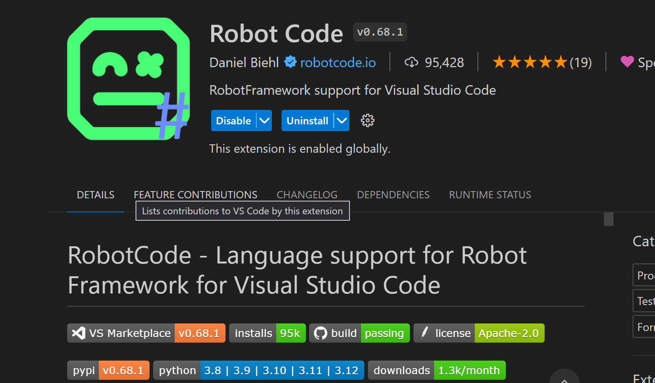

1. After instlalling the plugin open either of the two test files

* LoginTest.robot
* Testcalculator.robot

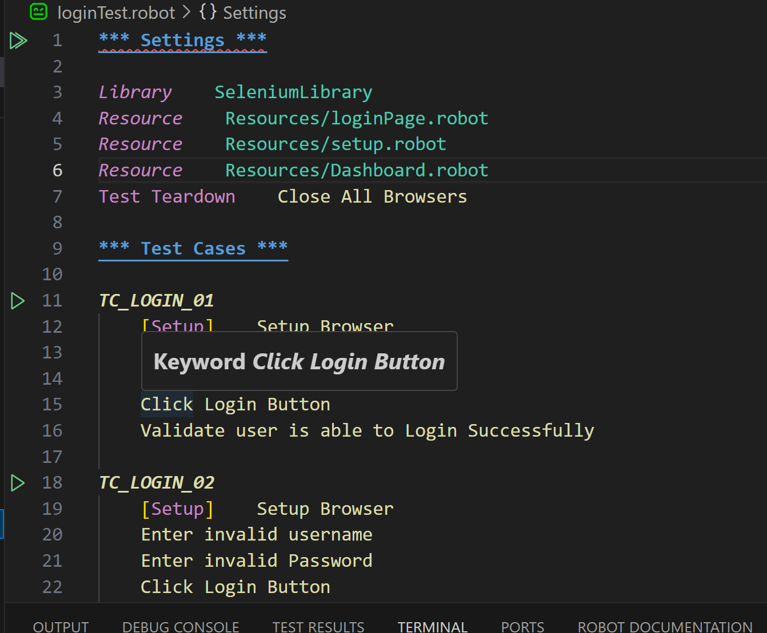

Click on green play button to run the test or click play button on top to run the whole test suite

Features of the framework

1. Used page object model to make framework easy to be updated and maintained
2. Developed custom excel library to facilitate adding more test instances easily
3. Developed small python libraries to facilitate small functionalities such as removing comma or space from the string.